Advanced Topics in Mathematics Name

Lesson 2.1 - Polynomial Operation Review Date

Find the Area of the Shaded Region

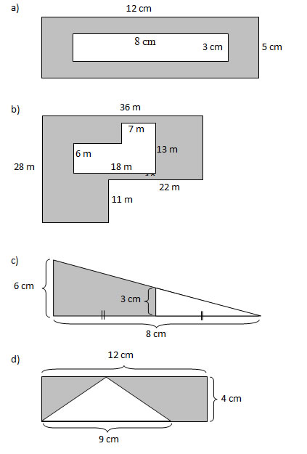

1. Find the Perimeter of the Rectangle.





1. Find the area and perimeter of the rectangle below. A = P =

(3x + 8)

(2x+6)

1. Find the Area of the Unshaded Region.





1. Find the Area of the Figure





1. Find the volume of the prism.   
   

(x – 4)

(x+1)

(2x+1)

1. Find the shaded area.

2x

(3x+2)

(x+7)

(x – 3)

1. Find the area of the shaded region.
2. Find the area of the shaded region.





1. Find the area of the shaded region.