STEP ONE: Go To the Boone County Public Library Website – www.bcpl.org

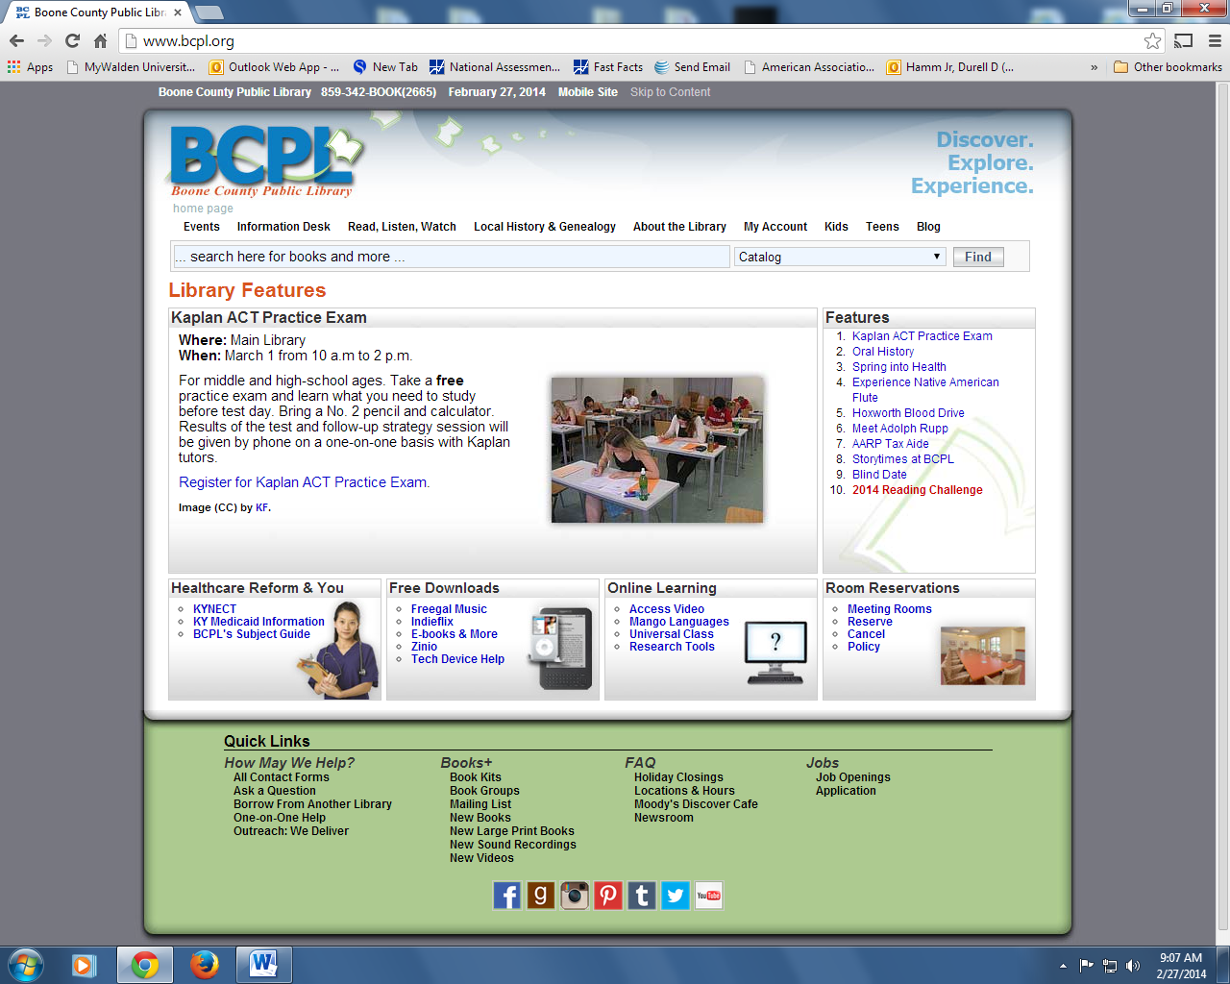
STEP 2: Click on Information Desk

STEP 3: Click on Research Tools
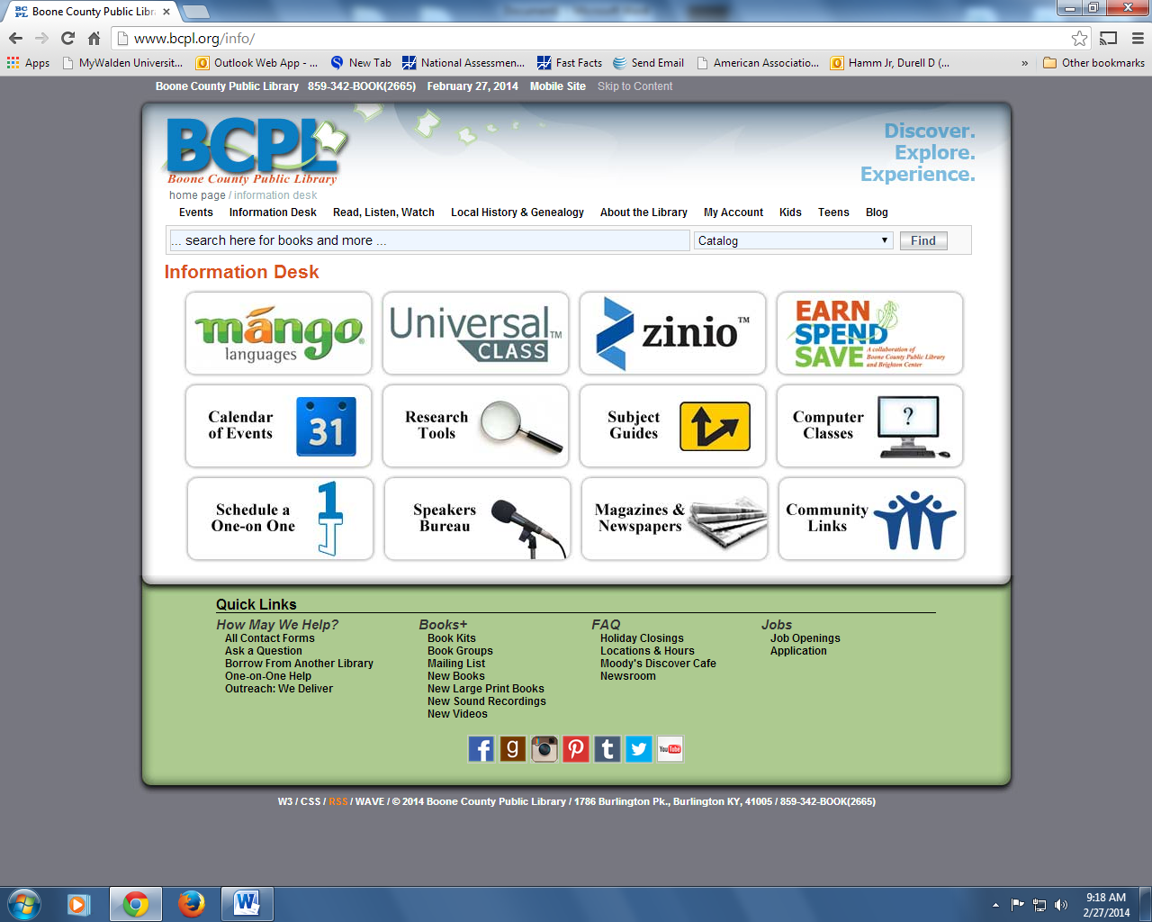

STEP 4: Scroll down to Education and Lifelong Learning and Click on Learning Express Library.

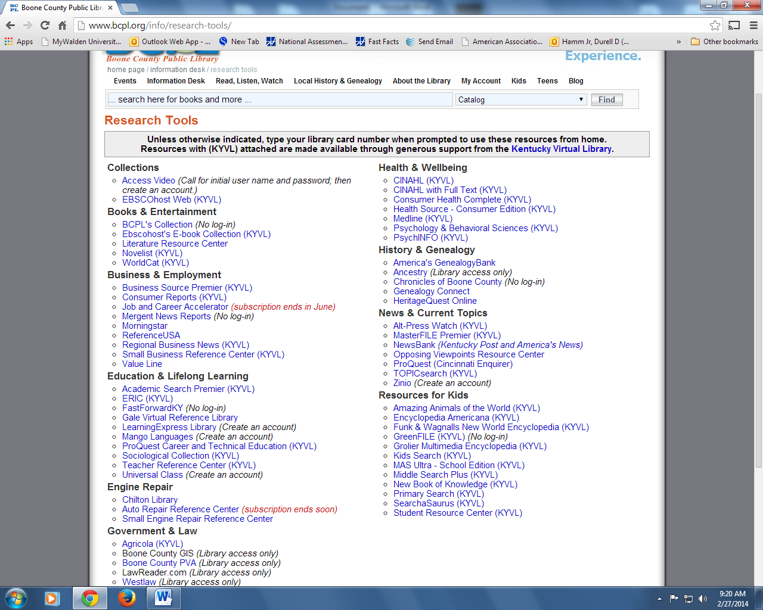

STEP 5: Click on College Preparation.
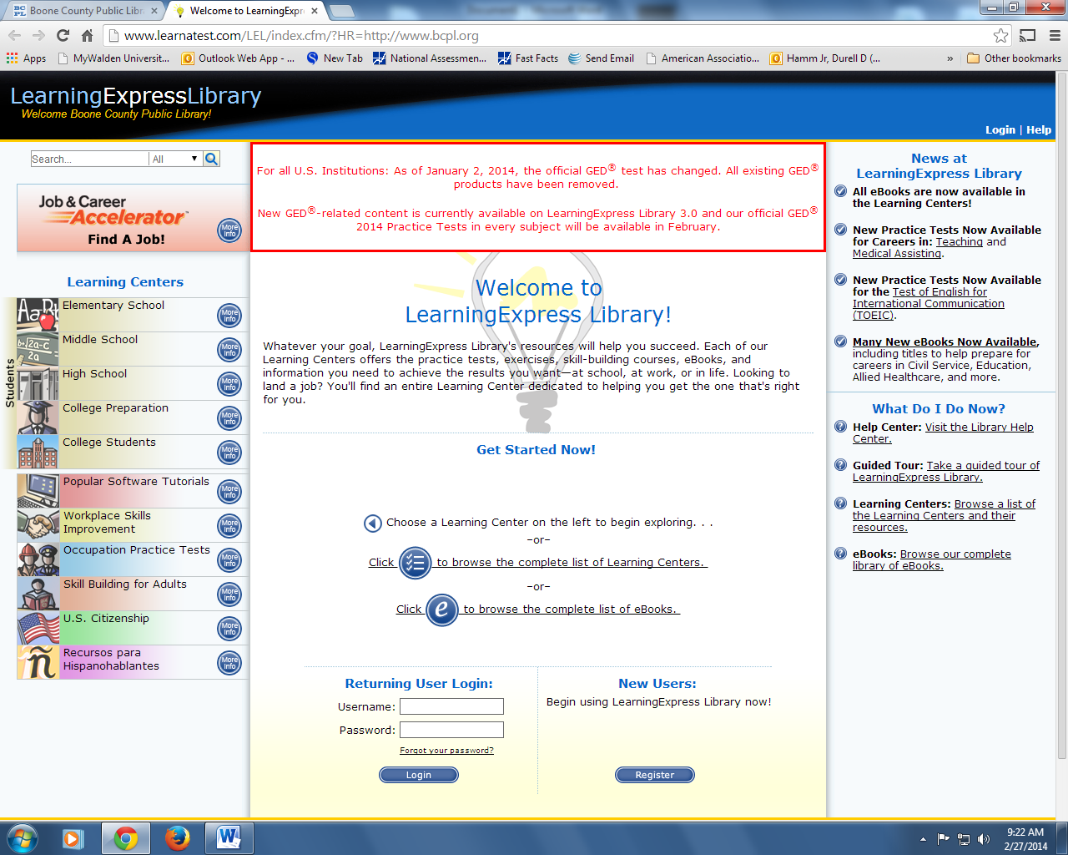

STEP 6: ACT Preparation (Note there is also AP Prep)

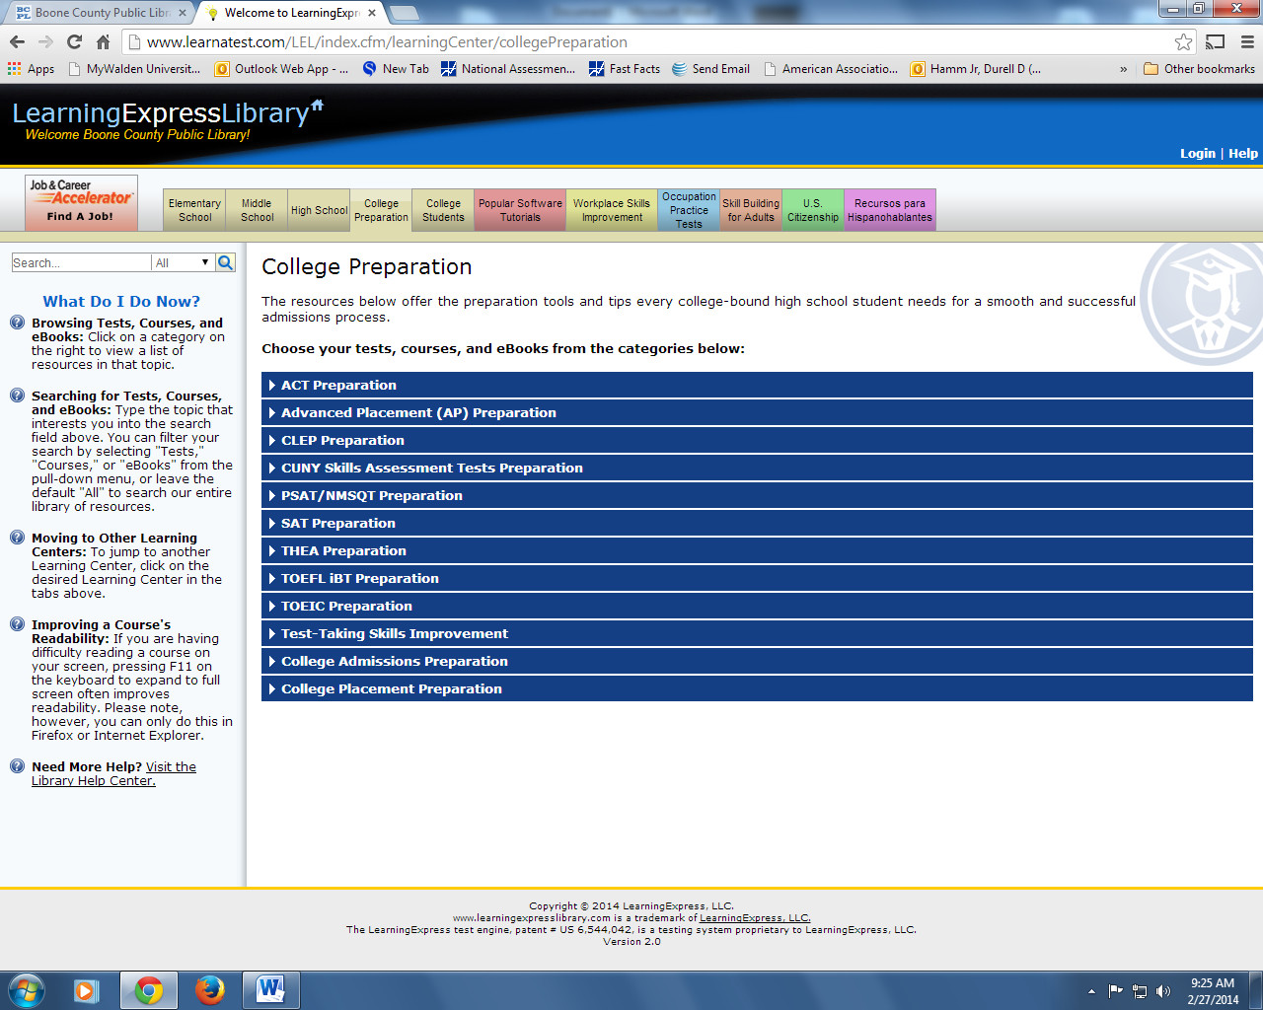

STEP 7: Note the ACT Test Prep Guides AND ACT Subject Practice Tests

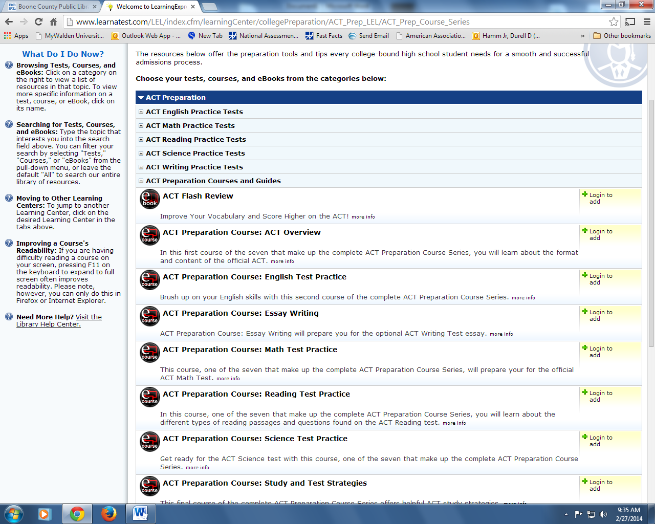

IMPORTANT INFORMATION: All of the tests are under timed conditions. In order to practice with the tests, students must have a Boone County Public Library card. What is nice about this website is it gives the student feedback on areas he or she needs to strengthen before taking the actual test. For instance, if a student does poorly on punctuation, the test will direct them to specific areas for improvement.
THIS IS A SUPERB SITE FOR STUDENTS TO PRACTICE.
BUTCH

