Advanced Topics in Math NAME
Create Tessellations DATE
- Go to the website: http://www.shodor.org/interactivate/activities/Tessellate/
- Select a shape to start with. Notice the options are those that already tessellate.
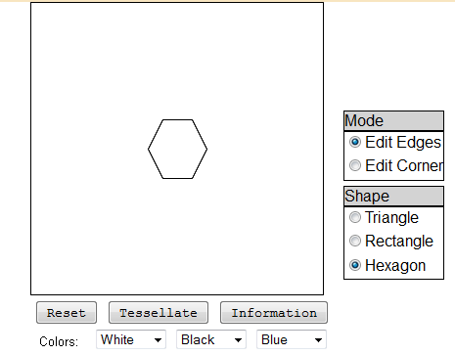
- We create alternate shapes using transformations. The program here will only allow for translations - meaning whatever shape you drag from one side will be placed on the opposite side, using the Edit Edge tool.
- Practice creating Letter M.
Place your cursor on the midpoint of the top edge. Click and drag down desired length.
- Place cursor as indicated above. Click and drag the edge up similar to the picture below.
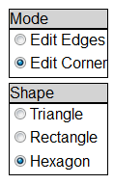
- Do the same with the other side.
- You can clean up any loose edges by the Edit Corner Tool.
Click and drag the bottom corner up.
- Now Tessellate! Change colors, rotate to see the image differently.
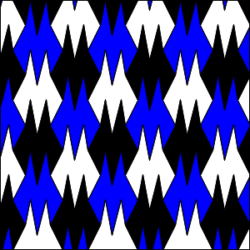 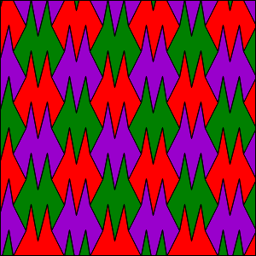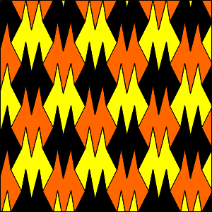
- What would happen if we started with a rectangle?
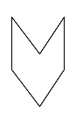 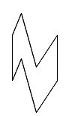 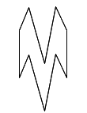 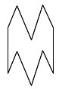 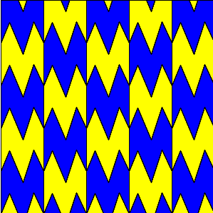

Advanced Topics in Math NAME
Create Tessellations DATE
TASK: Create tessellations of at least four letters in your name.
When printing the image, turn the color to all WHITE!!!
When your tessellation is created, right-click and select Save Image As….
Name the letter and save in the My Pictures folder.
Now paste the pictures on the next sheet. Type in your name at the top of the sheet. Print the sheet and turn in at the end of class.

Advanced Topics in Math NAME
Creating Tessellations DATE

