Advanced Topics in Math NAME   
Trigonometric Ratios Review

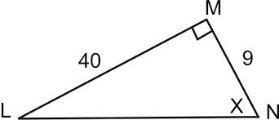**For each sketch, identify the indicated trig ratios.**

1. 1. 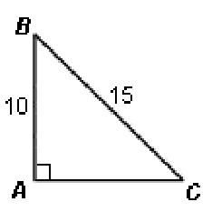
2. 1. 
4. 

**For each problem below, sketch a triangle that satisfies the given trig ratio. Then find the indicated trig ratio.**

$\sin{θ=\frac{9}{14}}$

$\cos{θ=}$

$\tan{θ=}$

$\cos{θ=\frac{5}{13}}$

$\sec{θ=}$

$\tan{θ=}$

2. In triangle *XYZ,* where *Z* is the right angle*,* what is $\cos{X}$ *i*f $\sin{X=\frac{3}{5}}$?

Advanced Topics in Math NAME   
Trigonometric Ratios Review

**For each sketch below, identify one positive and one negative coterminal angle.**

1. 
2. 
3. 
4. 

**For each angle θ below, determine the value of sine, cosine, and tangent.**

1. 
3. 

Advanced Topics in Math NAME   
Trigonometric Ratios Review ANSWERS

**For each sketch, identify the indicated trig ratios.**



41

* 1. 

1. 3. 

3



1. 

**For each problem below, sketch a triangle that satisfies the given trig ratio. Then find the indicated trig ratio.**



$\sin{θ=\frac{9}{14}}$

$$14$$

$$9$$

$$\sqrt{115}$$

$$θ$$

$\cos{θ=}$ $\frac{\sqrt{115}}{14}$

$$13$$

$$12$$

5



$$θ$$

$\tan{θ=}$ $\frac{9}{\sqrt{115}}=\frac{9\sqrt{115}}{115}$

$\cos{θ=\frac{5}{13}}$

$\sec{θ=}$ $\frac{13}{5}$

$\tan{θ=} \frac{12}{5}$

1. In triangle *XYZ,* where *Z* is the right angle*,* what is $\cos{X}$ *i*f $\sin{X=\frac{3}{5}}$? $\cos{X=\frac{4}{5}}$

3

$$3^{2}+x^{2}=5^{2} \\ x^{2}=5-3^{2} \\ x= \sqrt{5^{2}-3^{2}} \\ x=\sqrt{16}=4$$

Advanced Topics in Math NAME   
Trigonometric Ratios Review

**For each sketch below, identify one positive and one negative coterminal angle.**

1.    
     
     
     
   396 and -324
2. 
3.   
     
     
     
     
     
   660 and -60
4. 

240 and -480  
  
 -60 and 300

**For each angle θ below, determine the value of sine, cosine, and tangent.**

$$\sin{θ=}-\frac{15}{17} \\ \cos{θ=}\frac{8}{17} \\ \tan{θ= }-\frac{15}{8}$$

1. 

5

3

4

$$\sin{θ=}-\frac{12}{13} \\ \cos{θ=}-\frac{5}{13} \\ \tan{θ}=\frac{12}{5}$$

$$\sin{θ=}\frac{4}{5} \\ \cos{θ=\frac{3}{5}} \\ \tan{θ= }\frac{4}{3}$$

2. 

17

-15

8