Algebra II NAME ________________________________  
Writing and Solving Linear Inequalities

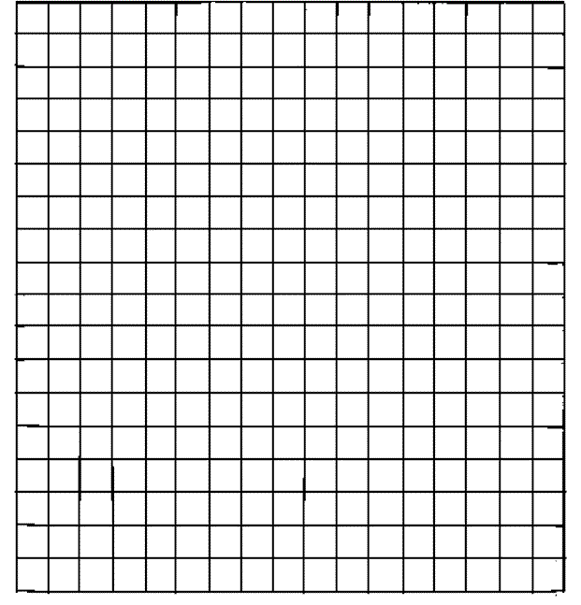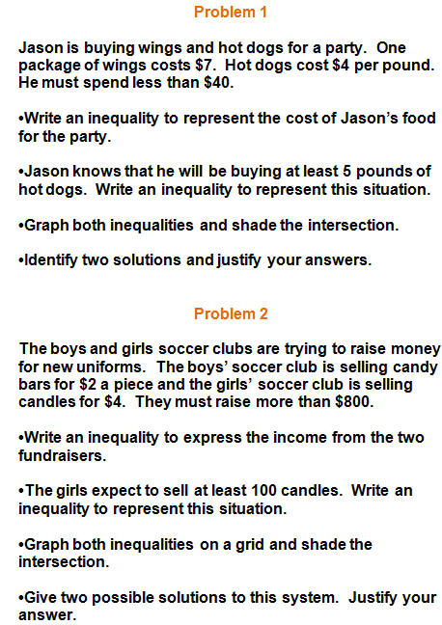



**Problem 3**

